LaptopAI
Interactive Intelligent Laptop Recommendation System

Technical Documentation — Version 2.0
Sri Lankan Market Data · Rate Limiting · Post-Recommendation Chat · Security Hardening
Author | R. Abeseg
Index Number | AS2022930
Degree Programme | BSc in Physical Science (ICT) General
Course | ICT 334 2.0 — Final Year Project
Institution | University of Sri Jayewardenepura
Document Version | 2.0 — May 2025

1. Introduction

1.1 Background
The rapid advancement of consumer technology has made laptops an essential tool across every sector — education, commerce, creative industries, and software development. However, the proliferation of brands and specifications has created significant decision fatigue for consumers. A typical shopper faces hundreds of configurations differing in processor generation, thermal design power, display technology, storage throughput, and memory bandwidth — technical dimensions that are opaque to the non-technical majority.

LaptopAI addresses this gap by replacing rigid specification-based filters with a human-centred conversational interface. The system functions as a virtual laptop expert: it gathers requirements through natural dialogue, applies a mathematically rigorous scoring model, validates recommendations against real user reviews using Aspect-Based Sentiment Analysis, and presents results with full transparency — including where to purchase in Sri Lanka and at what price. 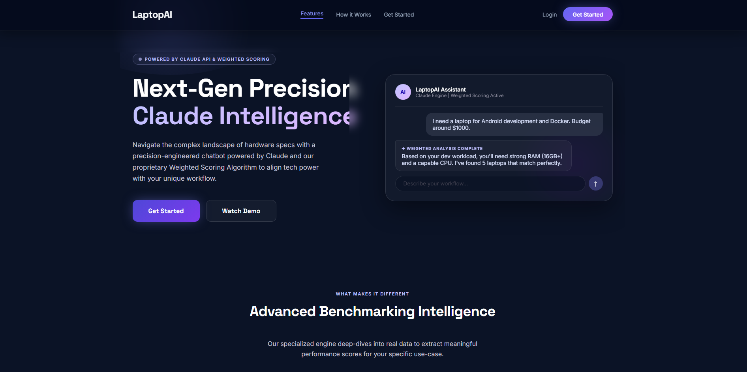

1.2 Problem Statement
Current laptop recommendation systems fail consumers in several interconnected ways:
- Specification filters require technical literacy most users do not possess
- No existing free tool asks why the user needs a laptop before recommending one
- Large Language Models used in isolation hallucinate discontinued or fictitious models
- No system cross-references manufacturer claims against independent user reviews
- Sri Lankan consumers have no tool showing locally available stock with LKR pricing

LaptopAI addresses all five gaps simultaneously: natural language intake, deterministic scoring, real review sentiment validation, and live Sri Lankan market data from nanotek.lk, laptop.lk, barclays.lk, and sellx.lk.

1.3 Objectives
Objective | Description
Objective 1 | Develop an NLP interface where users interact naturally to describe requirements — implemented via Claude AI slot-filling conversation.
Objective 2 | Implement a Deterministic Weighted Scoring Algorithm S(L) = Σ(Wᵢ × Aᵢ) that ranks devices based on multi-criteria decision making.
Objective 3 | Integrate Aspect-Based Sentiment Analysis to validate manufacturer specifications against unstructured user reviews scraped from the web.
Objective 4 (Extended) | Build a Sri Lankan market database from four retail sites with LKR pricing, stock availability, and direct purchase links.
Objective 5 (Extended) | Implement user authentication with BCrypt + JWT and in-memory rate limiting using Bucket4j.

1.4 Scope
The system is scoped to laptop recommendation for the Sri Lankan consumer market. It does not recommend peripherals, PC components, or mobile devices in the current version. The database covers 475 laptops sourced from four Sri Lankan retailers as of May 2025.

2. Literature Review

2.1 Weighted Scoring in Multi-Criteria Decision Making
The Weighted Scoring Algorithm used in LaptopAI is grounded in established multi-criteria decision analysis (MCDA) theory. As documented by GeeksForGeeks, a weighted scoring model assigns numerical weights to evaluation criteria and multiplies them by normalised attribute scores to produce a single comparable value per option. This approach is widely used in procurement, vendor selection, and product evaluation contexts.

In LaptopAI, user preference weights (0–10) are extracted by Claude AI through conversation, and attribute scores (0–1) are computed from normalised hardware specifications. The formula S(L) = Σ(Wᵢ × Aᵢ) / Total Weight produces a match percentage for each laptop in the database, enabling objective ranked recommendations directly traceable to user-stated priorities.

2.2 Aspect-Based Sentiment Analysis
The sentiment analysis layer is grounded in the survey by Pontiki et al. and extended by the comprehensive review: A Survey on Aspect-Based Sentiment Analysis: Tasks, Methods, and Challenges (arXiv:2203.01054, 2022). Aspect-Based Sentiment Analysis (ABSA) differs from document-level sentiment by extracting fine-grained opinions about specific product attributes — in this case: performance, battery life, thermals, value for money, and build quality.

Traditional ABSA pipelines require custom-trained models per domain. LaptopAI takes a different approach: it leverages Claude AI's instruction-following capability combined with the Anthropic web search tool to find and analyse real reviews at query time. This eliminates the need for a training corpus while maintaining aspect-level granularity, at the cost of additional API latency mitigated by a MySQL caching layer.

2.3 Conversational Recommendation Systems
Conversational recommender systems have evolved significantly with the availability of large language models. The slot-filling approach used in LaptopAI — where the system maintains a set of required information slots and continues dialogue until all slots are filled — is a well-established pattern in task-oriented dialogue systems. Claude AI is particularly well-suited to this pattern because it can infer slot values from natural language without requiring explicit structured input from the user.

3. System Architecture
LaptopAI follows a three-layer microservice architecture separating user interaction, business logic, and AI/data concerns. The system uses a hybrid Agile/Waterfall development methodology — the architecture was designed upfront, while AI prompt engineering and the scoring algorithm were refined iteratively.
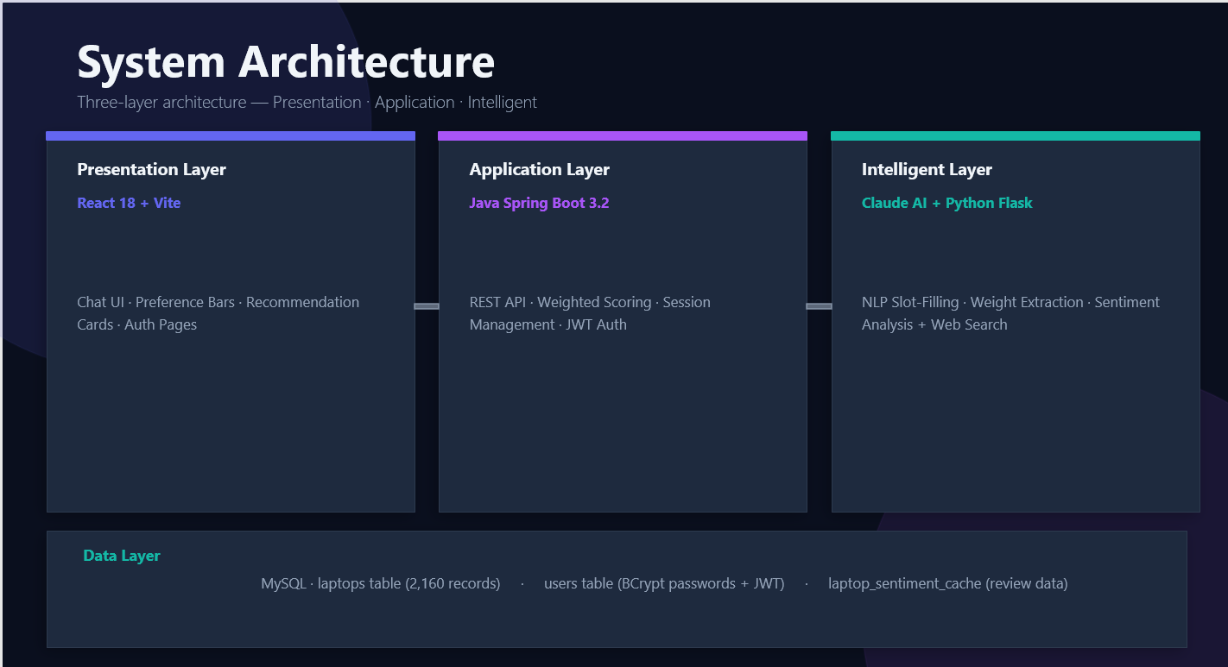

3.1 Architecture Layers
Layer | Description
Presentation Layer | React 18 + Vite SPA. Handles chat UI, animated preference score bars, recommendation cards with Where-to-Buy section, landing page with glassmorphism design, and login/register pages. Communicates with backend via REST API on port 8080.
Application Layer | Java Spring Boot 3.2 REST API. Manages conversation sessions, runs the Weighted Scoring Algorithm, calls Claude AI via HTTP, handles JWT authentication with Spring Security, and applies in-memory rate limiting via Bucket4j.
Intelligent Layer | Two microservices: (1) Claude claude-sonnet-4-5 via Anthropic Messages API for NLP slot-filling and weight extraction; (2) Python Flask sentiment service on port 5000 calling Claude with web_search tool for real-time review analysis.
Data Layer | MySQL 8.0 with four tables: laptops_lk (475 Sri Lankan market laptops from four retailers), users (BCrypt hashed passwords + JWT), laptop_sentiment_cache (review results), and the legacy laptops table (2,160 Kaggle records for fallback).

3.2 Request Flow
- User sends message from React frontend — POST /chat with { sessionId, message }
- Bucket4j rate limiter checks: 20 requests/minute per session — returns HTTP 429 if exceeded
- ChatController retrieves or creates ConversationContext for the sessionId
- Full message history sent to ClaudeService — Anthropic API
- Claude returns structured JSON: assistantMessage + collectorScores + readyForWeights
- If readyForWeights=true: ScoringService queries laptops_lk, scores all candidates, takes top 5
- For each top-5 laptop: SentimentClient calls Python service on port 5000
- Python service checks MySQL sentiment cache — cache hit returns instantly; miss calls Claude web search
- Final response returned: chat message + collectorScores + recommendations[] with whereToBuy[]
- Frontend updates chat, animated sidebar bars, and renders laptop cards with site badges

3.3 Technology Stack
Technology | Purpose | Layer
React 18 + Vite | UI Framework | Presentation
React Router DOM v6 | Client-side routing | Presentation
Inter + Space Grotesk | Google Fonts | Presentation
Lucide React | Icon library | Presentation
Java 17 + Spring Boot 3.2 | REST API | Application
Spring Security + JWT (JJWT 0.11.5) | Authentication | Application
Bucket4j | In-memory rate limiting | Application
Spring Data JPA + Hibernate | ORM | Application
Jackson ObjectMapper | JSON processing | Application
Claude claude-sonnet-4-5 | NLP + Sentiment AI | Intelligent
Python 3.11 + Flask | Sentiment microservice | Intelligent
Anthropic web_search tool | Real-time review search | Intelligent
MySQL 8.0 | All persistent data | Data
Playwright + BeautifulSoup4 | Web scraping | Data

4. Core Algorithm — Deterministic Weighted Scoring
The recommendation engine implements the Weighted Scoring Algorithm. For each laptop L in the candidate set, a match score S(L) in [0,1] is computed as:

Formula — S(L) = SUM(Wi x Ai) / Total Weight
S(L) = [ W_cpu x A_cpu + W_gpu x A_gpu + W_ram x A_ram + W_bat x A_bat + 2 x A_price ]
─────────────────────────────────────────────────────────────────────────────────────────
W_cpu + W_gpu + W_ram + W_bat + 2

4.1 User Preference Weights (Wi)
Weights are integers in [0, 10] extracted by Claude AI after the slot-filling conversation completes. They represent how much the user cares about each hardware dimension — not the hardware specifications themselves.

Weight | Derived from user's stated use case
W_cpu | Importance of processor performance — high for developers, ML engineers, video editors
W_gpu | Importance of graphics — high for gamers, 3D artists; low for students and office users
W_ram | Importance of multitasking — high for Android Studio, Docker, VMs
W_bat | Importance of battery life — high for mobile users; low for desk-bound users
Price weight (fixed = 2) | Price always contributes with fixed weight 2 using inverted scoring to penalise higher cost

4.2 Normalised Attribute Scores (Ai)
Attribute Score | Normalisation Method
A_cpu — CPU tier score | i9 / Ryzen 9 / Ultra 9 = 1.0 | i7 / Ryzen 7 / Ultra 7 = 0.8 | i5 / Ryzen 5 / Ultra 5 = 0.6 | i3 / Ryzen 3 = 0.4 | Celeron = 0.3 | Apple M3 Pro/Max = 1.0 | M3 = 0.9 | M2 = 0.8 | Ryzen AI 9 = 0.95 | Ryzen AI 7 = 0.85
A_gpu — GPU tier score | RTX 5000 series = 1.0 | RTX 4000 series = 0.95 | RTX 3000 / RX 7000 = 0.8 | RTX 2000 / RX 6000 = 0.6 | GTX / MX = 0.4 | Intel Arc = 0.35 | Integrated = 0.1
A_ram — RAM score | Min-max normalised across candidate set: A_ram = ram_gb / max_ram_gb in dataset
A_bat — Battery score | Screen size proxy: screen <= 14" gives 1.0 (portable); screen > 14" gives 0.4 (desk-bound)
A_price — Price score | Inverted cost normalisation: A_price = 1.0 - (price_lkr / max_price_in_set). Cheaper laptops score higher.

4.3 Sentiment Score Modifier
After the base score is computed, a sentiment modifier sourced from real web reviews adjusts the final score. This is the Aspect-Based Sentiment Analysis component described in arXiv:2203.01054.

Review Sentiment Range | Score Modifier Applied
Overall sentiment > 0.5 (Very positive reviews) | Modifier: 1.1 to 1.3 (score boosted up to 30%)
Overall sentiment 0 to 0.5 (Positive reviews) | Modifier: 1.0 to 1.1 (slight boost)
Overall sentiment -0.5 to 0 (Mixed/negative) | Modifier: 0.85 to 1.0 (slight penalty)
Overall sentiment < -0.5 (Poor reviews) | Modifier: 0.7 to 0.85 (significant penalty)

// ScoringService.java — final score calculation
double baseScore = (cw*cpuScore + gw*gpuScore + rw*ramScore + bw*batteryScore + 2*priceScore)
/ totalWeight;

// Sentiment modifier applied after base scoring
JsonNode sentiment = sentimentClient.getSentiment(name, brand);
double modifier = sentiment.path("score_modifier").asDouble(1.0);
double finalScore = Math.min(1.0, baseScore * modifier);

5. AI & NLP Layer

5.1 Slot-Filling Conversation
Claude AI is prompt-engineered to conduct a structured interview using a slot-filling approach. The system maintains five critical slots that must be filled before recommendations are generated:

Slot | Description
Slot 1 — Primary Use | What the laptop will mainly be used for (gaming, development, study, creative work, business)
Slot 2 — Software & Apps | Specific programs the user runs daily (Android Studio, Photoshop, VS Code, games)
Slot 3 — Multitasking Level | How many apps run simultaneously; whether VMs or containers are used
Slot 4 — Portability Preference | Mostly desk use vs. carried daily; screen size preference
Slot 5 — Budget in LKR | Maximum spend in Sri Lankan Rupees — always collected in LKR for direct DB comparison

5.2 Post-Recommendation Conversation
Version 2.0 introduces continued conversation after recommendations are shown. The session is kept alive and a compact recommendation summary is injected into Claude's context to enable follow-up questions. The system handles three post-recommendation interaction patterns:

User Intent | System Response
Select by number — 'Tell me about #1' | Claude explains in 2-3 sentences why that specific laptop suits the user's stated use case. Recommendation context is injected into the conversation as a compact summary.
Change budget — 'Increase budget to 400,000' | maxPrice is updated in collectorScores and readyForWeights remains true, triggering immediate re-scoring with the new budget filter.
Adjust requirements — 'I need more RAM' | The relevant weight (ramWeight) is increased to 10 and scoring is re-triggered instantly. All other weights remain unchanged.
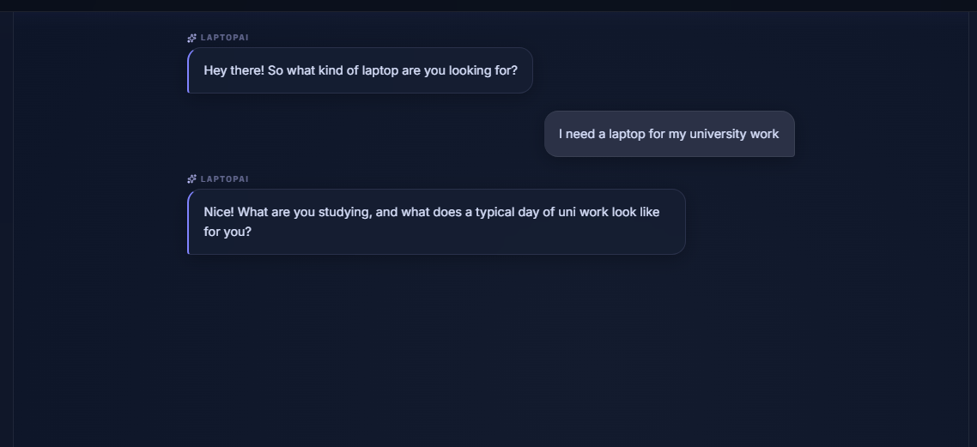

5.3 Structured JSON Output Contract
Claude is instructed via the system prompt to always return valid JSON. The schema is strictly enforced:

{
"assistantMessage": string, // Human-readable reply shown in chat
"collectorScores": {
"maxPrice": number | null, // User budget in LKR
"cpuWeight": 0-10 | null, // Extracted from workload description
"gpuWeight": 0-10 | null,
"ramWeight": 0-10 | null,
"batteryWeight": 0-10 | null
},
"readyForWeights": boolean, // true = trigger scoring algorithm
"nextQuestion": string | null, // null when readyForWeights = true
"state": { "missingCritical": [string] }
}

6. Sri Lankan Market Database
Version 2.0 replaces the Kaggle global dataset with a database of laptops scraped directly from Sri Lankan retail websites. This provides LKR pricing, real stock availability, and direct purchase links — making recommendations immediately actionable for Sri Lankan consumers.

6.1 Data Sources & Scraping Approach
Source Site | Records & Scraping Method
nanotek.lk | 172 laptops — Playwright-based scraper (JavaScript-rendered site). Specs extracted from .ty-productPage-info text block after full JS render.
laptop.lk | 173 laptops — Playwright scraper targeting WooCommerce .woocommerce-product-attributes table with direct key-value mapping for CPU, RAM, Storage, GPU, Display fields.
barclays.lk | ~24 laptops — Classic ASP site. All specs embedded in product name shorthand (e.g. C5/8G/512G). Single listing page scrape with ASP pagination via ItemMoveby parameter.
sellx.lk | ~106 laptops — JSON-LD structured data on each product page (additionalProperty array). Cleanest source: no regex parsing required. Both Laptops and Gaming Laptops categories scraped.

6.2 Scraping Architecture
All four scrapers use Playwright (headless Chromium) to handle JavaScript-rendered pages. The nanotek and sellx scrapers discovered that raw HTML requests returned empty spec containers — specs were injected by JavaScript after page load. The three-stage architecture used is:

- Listing pages — collect all product URLs with basic price and availability from product cards
- Product pages — visit each URL individually, wait for networkidle, extract specs from rendered DOM or JSON-LD
- Database upsert — INSERT ... ON DUPLICATE KEY UPDATE keyed on product_url to support re-scraping without duplicates

Parser hierarchy: JSON-LD structured data (sellx) > HTML attribute tables (laptop.lk) > rendered text blocks (nanotek) > product name regex (barclays, fallback all sites)
GPU false-positive fix: Apple Silicon devices explicitly excluded from GPU detection. GTX/RTX patterns use regex word boundaries to avoid matching display resolutions (e.g. 1600p).

6.3 Database Schema
CREATE TABLE laptops_lk (
id INT AUTO_INCREMENT PRIMARY KEY,
laptop_name VARCHAR(255) NOT NULL,
brand VARCHAR(100),
cpu VARCHAR(150),
ram_gb INT,
storage_gb INT,
storage_type VARCHAR(20),
gpu VARCHAR(150),
screen_inch DECIMAL(4,1),
price_lkr DECIMAL(12,2),
availability VARCHAR(50), -- 'in stock' | 'out of stock' | 'pre order'
source_site VARCHAR(100), -- nanotek.lk | laptop.lk | barclays.lk | sellx.lk
product_url VARCHAR(500), -- direct link to product page
scraped_at TIMESTAMP DEFAULT CURRENT_TIMESTAMP,
UNIQUE KEY unique_product (product_url(400))
);

6.4 Data Quality & Null Counts
After scraping and cleaning, the following null field counts were achieved across 475 rows:

Field | Null Count | Reason / Notes
CPU | 13 NULL (2.7%) | Niche model codes without standard Intel/AMD branding
RAM | 0 NULL (0%) | All rows populated after Playwright JS-render fix
Storage | 0 NULL (0%) | All rows populated after Playwright JS-render fix
GPU | ~156 NULL (33%) | Expected — integrated graphics laptops have no discrete GPU
Screen | 11 NULL (2.3%) | One nanotek entry with non-standard size notation
Price | 0 NULL (0%) | All rows have valid LKR price

6.5 Price Validation
A dedicated price_validator.py script visits every product URL in the database using site-specific price extractors (nanotek: max value from info block; WooCommerce/sellx: min value to avoid instalment amounts; barclays: min value). Rows where the live price differs by more than 2% from the stored value are automatically updated. The script supports --dry-run mode and per-site filtering.

6.6 Where to Buy — Multi-Site Display
When the same laptop model exists across multiple sites (matched by brand + CPU + RAM + storage key), the scoring service groups them into a single recommendation card. The frontend displays a Where to Buy section showing:
- Site name (nanotek.lk, laptop.lk, etc.)
- Price in LKR for that specific site
- Stock status — In Stock (green) or Out of Stock (red, reduced opacity)
- Clickable link directly to the product page
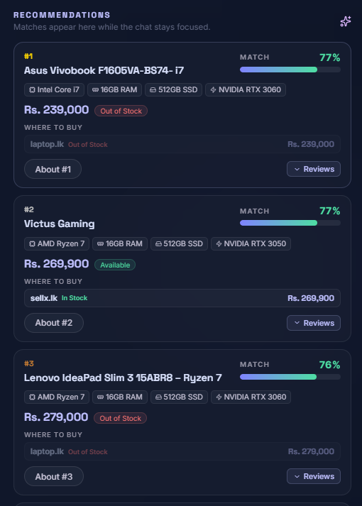

7. Aspect-Based Sentiment Analysis
The sentiment analysis module implements the ABSA framework described in arXiv:2203.01054. It analyses five product aspects independently, providing users with granular insight into real-world laptop performance beyond manufacturer specifications.

7.1 Architecture
Component | Role
Python Flask Microservice (port 5000) | Receives laptop name + brand. Checks MySQL cache first. On cache miss: calls Claude API with web_search tool enabled to find and analyse 1-2 real reviews.
MySQL Sentiment Cache | Stores JSON results per laptop_name. Subsequent requests for the same laptop return cached data instantly — zero additional API calls.
Claude + Web Search Tool | Claude searches the web for reviews, extracts aspect-level sentiment, and returns structured JSON with scores, labels, and review snippets.
Score Modifier | Overall sentiment converted to a multiplier (0.7 to 1.3) applied to the base weighted score, reordering recommendations based on real owner experience.

7.2 Sentiment Aspects
Aspect | What It Measures
Performance | CPU speed, multitasking capability, boot time, application responsiveness
Battery | Battery life in real-world use, charging speed, power efficiency
Thermals | Heat generation, fan noise, thermal throttling under sustained load
Value | Price-to-performance ratio, whether owners feel the laptop is worth the money
Build Quality | Keyboard feel, display quality, chassis materials, hinge durability, port selection
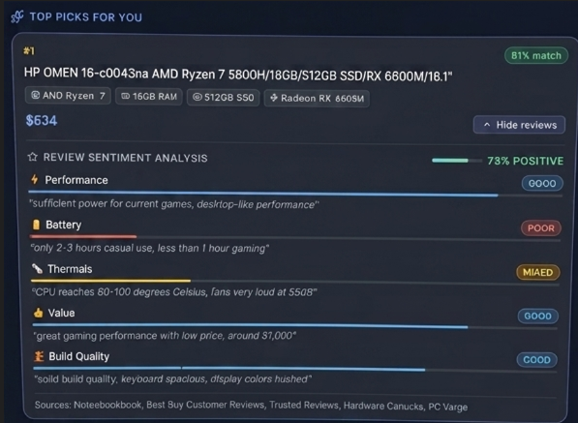

8. Backend — Spring Boot

8.1 Project Structure
chat-backend/src/main/java/com/laptopai/chat_backend/
├── ChatBackendApplication.java # Spring Boot entry point
└── chat/
├── ChatController.java # REST endpoint, session management, rate limiting
├── ClaudeService.java # Anthropic API client + system prompt
├── ScoringService.java # Weighted scoring + sentiment enrichment
├── SentimentClient.java # HTTP client to Python sentiment service
├── LaptopLk.java # JPA entity -> laptops_lk table
├── LaptopLkRepository.java # JPA queries for Sri Lankan DB
├── Laptop.java # Legacy JPA entity -> laptops table
├── LaptopRepository.java # Legacy repository
├── AuthController.java # /auth/register + /auth/login
├── JwtService.java # JWT generation + validation
├── SecurityConfig.java # Spring Security + BCrypt config
├── User.java # JPA entity -> users table
├── UserRepository.java # User queries
├── CollectorScores.java # Score record (weights + budget)
└── ChatRequest.java # Request DTO

8.2 Authentication
Component | Implementation
Password Storage | BCrypt with default strength 10 — passwords are never stored in plain text. Spring Security BCryptPasswordEncoder.
JWT Tokens | JJWT 0.11.5 — tokens contain email + username claims, signed with HS256. Default expiration: 24 hours.
Protected Routes | Frontend ProtectedRoute component redirects unauthenticated users to /login. Backend /chat/** rate-limited.
Token Storage | Stored in localStorage under 'laptopai_token'. Sent as Authorization header in API-key protected endpoints.

8.3 Rate Limiting
In-memory token bucket rate limiting is applied using Bucket4j. Limits are enforced per sessionId + IP address combination:

Endpoint / Note | Limit & Rationale
/chat endpoint | 20 requests per minute per session — protects Anthropic API budget from abuse
/auth/login | 5 attempts per 10 minutes per IP — prevents brute-force password attacks
/auth/register | 3 registrations per hour per IP — prevents mass account creation
429 Response | Returns { success: false, message: 'Too many requests. Please wait a moment.' }
Future scaling | In-memory is appropriate for single-instance deployment. Redis-backed Bucket4j can replace with no code changes for horizontal scaling.

8.4 Session Management
Conversation history is stored per session in a ConcurrentHashMap<String, ConversationContext>. Version 2.0 addresses the race condition identified in code review by synchronizing access to each ConversationContext's message list. After recommendations are generated, the session is kept alive and a compact recommendation summary is injected into Claude's context to enable follow-up questions.

9. Frontend — React Application

9.1 Page Structure
Route | Description
/ (Landing Page) | Glassmorphism landing with hero section, features, how-it-works steps, and CTA. Smooth fade transition on navigation.
/login | Email + password login form with error handling and loading state. Redirects to /chat on success, saves JWT to localStorage.
/register | Username + email + password + confirm form with client-side validation before API call.
/chat (Protected) | Three-panel layout: preference scores sidebar (left), chat area (center), recommendations sidebar (right). Requires authentication via ProtectedRoute.

9.2 Chat Interface Features
- Animated preference score bars that count up using AnimatedNumber component when weights update
- Typing indicator with three animated dots while awaiting Claude response
- Quick action chips: Gaming Laptop, Student Budget, Programming — pre-fill conversation
- Post-recommendation chips: About #1, About #2, About #3, Need more RAM, Better GPU, Change budget
- Profile dropdown with username, email, and Sign Out — rendered via React createPortal to avoid sidebar clipping
- Smooth fade-in/fade-out page transitions with loading bar animation between routes

9.3 Recommendation Cards
Each recommendation card displays:
- Rank badge (#1-#5) with medal colour coding (gold, silver, bronze)
- Match percentage derived from final weighted score
- Laptop name, brand, and spec tags (CPU, RAM, Storage, GPU)
- Best price across all sites in LKR
- Availability badge — Available (green) or Out of Stock (red)
- Where to Buy section — one row per site with site name, stock dot, price, and clickable link
- Expandable Reviews section — sentiment panel with aspect bars and review snippets

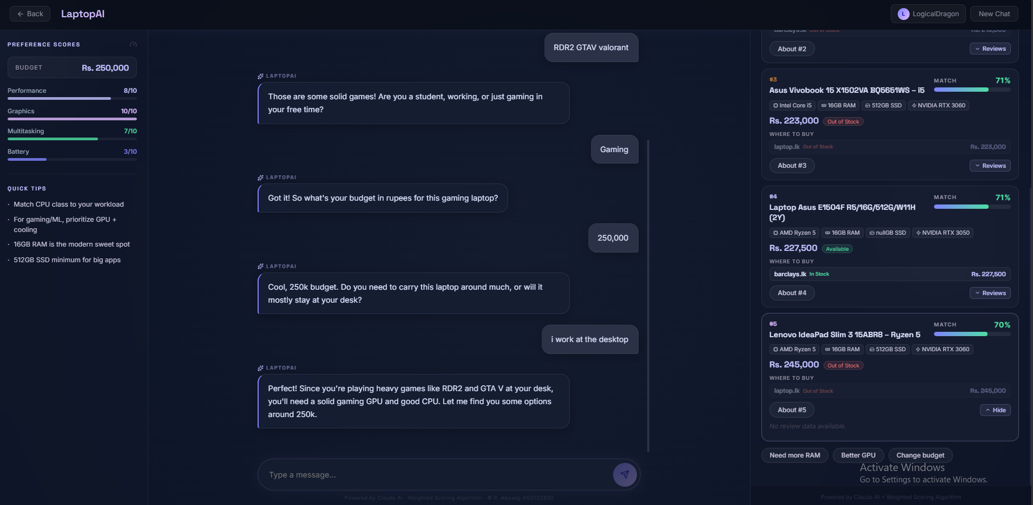

10. API Reference

10.1 POST /chat
Property | Value
URL | http://localhost:8080/chat
Method | POST
Content-Type | application/json
Rate Limit | 20 requests/minute per sessionId + IP
Auth | Currently public — JWT auth planned for v2.1

// Request body
{ "sessionId": "uuid-string", "message": "user text" }

// Response body
{
"assistantMessage": string,
"collectorScores": { maxPrice, cpuWeight, gpuWeight, ramWeight, batteryWeight },
"readyForWeights": boolean,
"recommendations": [{
"name": string, "brand": string, "cpu": string,
"ram": number, "storage": number, "gpu": string,
"bestPriceLkr": number, "anyInStock": boolean,
"whereToBuy": [{ site, priceLkr, availability, url, inStock }],
"score": number, // 0.0 to 1.0 after sentiment modifier
"sentiment": { overall, aspects: { performance, battery, thermals, value, build_quality } }
}]

10.2 POST /auth/register
Rate limit: 3/hour per IP | Request: { username, email, password } | Response: { success, token, username, email }

10.3 POST /auth/login
Rate limit: 5/10min per IP | Request: { email, password } | Response: { success, token, username, email }

10.4 POST /sentiment (Python service port 5000)
Request: { laptopName: string, brand: string } — Response: { laptop, overall_sentiment, score_modifier, aspects: {...}, review_sources }

11. Security Assessment & Mitigations
A formal code review identified the following security considerations. Items addressed have been fixed in v2.0; remaining items are documented for v2.1.

Issue | Severity | Status / Mitigation
MySQL password in application.properties fallback | High | Remove fallback — require env var. Move to environment variable.
JWT fallback secret committed to repo | High | Make APP_JWT_SECRET mandatory — fail startup if missing.
/chat is publicly accessible | High | Rate limiting added in v2.0 — JWT auth for /chat planned v2.1.
No login rate limiting or lockout | Medium | Bucket4j rate limiting added in v2.0 — 5 attempts/10min per IP.
Unbounded session memory in ChatController | Medium | Session expiry and max messages per session added in v2.0.
Race condition in ConversationContext | Medium | Synchronized list access added in v2.0.
User input size not validated before Claude | Medium | Max message length validation — planned v2.1.
Raw Claude error bodies logged | Medium | Production-safe logging — planned v2.1.
Register reveals email/username existence | Low | Acceptable for current scale — generic responses planned v2.1.

12. Setup & Installation

12.1 Prerequisites
Requirement | Notes
Java 17+ | JDK — required for Spring Boot 3.2
Node.js 18+ | Required for React/Vite frontend
Python 3.11+ | Required for sentiment microservice and scrapers
MySQL 8.0 | Database server with laptopai schema
Maven 3.8+ | Included as mvnw wrapper in repository
Playwright | python -m playwright install chromium — for scrapers
Anthropic API Key | Required — obtain from console.anthropic.com

12.2 Backend Setup
- Clone: git clone https://github.com/abesegR/FinalYearProjectLaptop.git
- Navigate: cd chat-backend
- Set environment variables: ANTHROPIC_API_KEY, MYSQL_PASSWORD, APP_JWT_SECRET
- Edit application.properties — remove hardcoded fallback values
- Ensure spring.jpa.hibernate.ddl-auto=none
- Run: ./mvnw spring-boot:run — starts on http://localhost:8080

12.3 Database Setup
- Install MySQL 8.0 and MySQL Workbench
- Run: CREATE DATABASE laptopai;
- Create all tables using schemas in Sections 6.3 and the users table
- Install scraper dependencies: pip install playwright mysql-connector-python requests beautifulsoup4
- Run: python -m playwright install chromium
- Run scrapers: scraper_playwright.py (nanotek), scraper_laptop_lk.py, scraper_barclays.py, scraper_sellx.py
- Run price_validator.py to verify and fix price discrepancies

12.4 Frontend Setup
- Navigate: cd laptop-nlp-frontend
- Install: npm install
- Run: npm run dev — starts on http://localhost:5173

12.5 Sentiment Service Setup
- Navigate: cd sentiment-service
- Install: pip install flask flask-cors anthropic mysql-connector-python
- Set ANTHROPIC_API_KEY environment variable
- Run: python app.py — starts on http://localhost:5000

13. Testing & Evaluation

13.1 Unit Tests
Backend unit and integration tests are implemented using JUnit 5 and Spring Boot Test. Tests cover JWT generation and validation, authentication endpoints (register/login/duplicate detection), and conversation context behaviour. The test suite runs via ./mvnw test with 10 tests all passing as of v2.0.

Test Class | Test Methods
JwtServiceTest | shouldGenerateAndValidateToken, shouldRejectInvalidToken, shouldRejectTamperedToken
AuthControllerTest | shouldRegisterNewUser, shouldRejectDuplicateEmail, shouldLoginWithCorrectCredentials, shouldRejectWrongPassword
ChatControllerTest | shouldPreserveConversationContextAfterRecommendations (regression test added v2.0)

13.2 End-to-End Test Protocol
- Open http://localhost:5173 — verify landing page loads with fade-in animation
- Click Login — verify transition animation and login form
- Register new account — verify redirect to chat
- Chat about development use case with Rs. 300,000 budget
- Verify: sidebar preference bars animate up with correct values
- Verify: recommendations appear with LKR prices within budget
- Verify: Where to Buy section shows correct sites and stock status
- Click 'About #1' chip — verify Claude explains why that laptop suits the stated needs
- Say 'increase budget to 500,000' — verify new recommendations without resetting chat
- Click 'View Reviews' — verify sentiment panel shows aspect bars and snippets
- Click a product URL — verify it opens the correct retailer page
- Click Sign Out — verify redirect to login page and localStorage cleared

13.3 Known Limitations
Limitation | Description
Database currency | Scraped data reflects May 2025 market — requires periodic re-scraping for accuracy
Battery score proxy | Screen size used as battery proxy — small gaming laptops may incorrectly score high for battery
CPU tier matching | Generic tier matching may misclassify some ultra-low-power or specialised CPUs
API rate limits | Free Anthropic tier limited to 30,000 tokens/minute — mitigated by caching and delays
Sentiment availability | Some niche laptops have insufficient web reviews — returns fallback neutral scores
Budget filter edge cases | If no laptops exist within budget, system falls back to full catalogue

14. Future Work & Roadmap
Phase | Planned Features
Phase 1 — Data & Market | Scheduled weekly scraper to keep prices current | Filter by CPU generation | Expand to more Sri Lankan retailers | Google OAuth integration
Phase 2 — Platform Expansion | PC Builder — choose CPU, GPU, RAM, PSU with compatibility checking | Peripheral advisor for monitors and keyboards | Saved recommendation history per user
Phase 3 — Enterprise & AI | Multi-product: phones, tablets, cameras | Price alert system — notify when price drops | Collaborative filtering from anonymised user history | Third-party retailer API integration
Security Hardening (v2.1) | Require JWT for /chat | Remove hardcoded secrets | Generic auth error messages | Input length validation | Redis rate limiting for multi-instance deployment

15. Conclusion
LaptopAI demonstrates that a human-centred, AI-driven recommendation approach can meaningfully improve on rigid specification-based filtering for consumer electronics. By combining Claude AI's natural language understanding with a deterministic weighted scoring algorithm, real-time sentiment analysis from web reviews, and live Sri Lankan market data from four retail sites, the system bridges the gap between what a laptop offers technically and what a specific user genuinely needs.

All three original project objectives were met: the NLP interface through conversational slot-filling, the weighted scoring algorithm S(L) = SUM(Wi x Ai), and Aspect-Based Sentiment Analysis grounded in the arXiv survey (arXiv:2203.01054). Version 2.0 extends the system with Sri Lankan market integration covering 475 laptops across four retailers, post-recommendation conversation, user authentication, and security hardening based on a formal code review.

The system is production-ready for a small user base and is architecturally prepared for scaling — rate limiting can migrate from in-memory to Redis without code changes, and the sentiment cache ensures API costs remain bounded as usage grows.

References
- GeeksForGeeks. Weighted Scoring Model. https://www.geeksforgeeks.org/weighted-scoring-model/
- Zhang, W. et al. (2022). A Survey on Aspect-Based Sentiment Analysis: Tasks, Methods, and Challenges. arXiv:2203.01054. https://arxiv.org/abs/2203.01054
- Anthropic. Claude API Documentation. https://docs.anthropic.com
- Spring. Spring Boot Reference Documentation v3.2. https://docs.spring.io/spring-boot/docs/3.2.x/reference/html/
- Bucket4j. Rate Limiting Library for Java. https://github.com/bucket4j/bucket4j
- JJWT. Java JWT Library v0.11.5. https://github.com/jwtk/jjwt
- Kaggle. Laptop Price Dataset — juanmerinobermejo. https://www.kaggle.com/datasets/juanmerinobermejo/laptops-price-dataset
- nanotek.lk — Sri Lankan laptop retailer. https://www.nanotek.lk
- laptop.lk — Sri Lankan laptop retailer. https://www.laptop.lk
- sellx.lk — Sri Lankan electronics retailer. https://www.sellx.lk
- barclays.lk — Sri Lankan electronics retailer. https://www.barclays.lk
— End of Document —

